Fact File
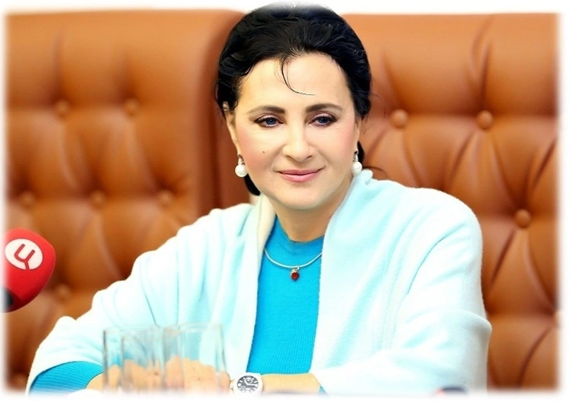
Set 3. Student 1. IRINA VINER

Irina Viner is Head Trainer of the Russian team, Head of the Russian Rhythmic Gymnastics
Federation and widely seen as a leading power broker in Russian sports.

Biography

Irina Alexandrovna Viner was born in Samarkand, Soviet Union, on July 30, 1948. Her father was a renowned painter, and her mother was a doctor. As a young girl, Viner aspired to become a ballet dancer but was discouraged from pursuing a career in dancing. Instead, she took up gymnastics at the age of 11. She graduated from the Uzbek State Institute of Physical Culture. Viner has a son, Anton, from her first marriage. He was born in 1973 and is now a businessman, president of the development company Khimki Groups.

Sporting career
Irina Viner's personal sports achievements in rhythmic gymnastics are remarkable. As a young gymnast, Viner quickly rose to prominence and became a three-time champion of the Uzbek SSR. Her talent and dedication led her to excel in the sport, showcasing her incredible skills and artistry. Viner's performances captivated audiences and established her as a trailblazer in rhythmic gymnastics.

Coaching career

Viner's career as a coach is nothing short of extraordinary. She is known for her talent to grow up Olympic champions. Viner's coaching journey began in Tashkent, where she worked as a coach of the national team in rhythmic gymnastics. Under her tutelage, Venera Zaripova became her first successful gymnast. In 1990, Viner briefly moved to Great Britain to coach the British national team. However, she eventually settled in Moscow and joined the Moscow City Sports Association (MCSA). In 2001, she was appointed Head Coach of the Russian National Team. Her dedication and expertise led to her appointment as President of the Russian Rhythmic Gymnastics Federation in 2008. Her pupils have achieved remarkable success in rhythmic gymnastics, with five of the last six Olympic all-around champions being trained by her. These champions include Margarita Mamun, Evgeniya Kanaeva, Alina Kabaeva, and Yulia Barsukova. Viner's coaching talent has also produced numerous Olympic, World, European, and World Cup medal winners.
Irina Viner's impact on rhythmic gymnastics is unparalleled. Her dedication, expertise, and ability to guide her pupils to glory have solidified her status as one of the most successful gymnastics coaches of all time. As President of the Russian Rhythmic Gymnastics Federation and head trainer of the Russian team, Viner continues to shape the future of this captivating sport.

Interesting facts
Viner's contributions to the world of gymnastics have not gone unnoticed. In 2015, she was awarded the Olympic Order, becoming the first gymnastics coach in history to receive this prestigious award. The Olympic Order was presented to her by Thomas Bach, the President of the International Olympic Committee.
In addition to her coaching accomplishments, Viner has also made appearances in the media. She was featured in the 2017 documentary "Over the Limit," which followed her training of Margarita Mamun in preparation for the 2016 Olympics.
She has always been fond of music. While at school, she played in the school theatre and enjoyed ballet dancing.

